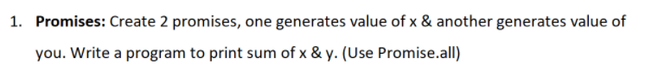

<!DOCTYPE html>

<html>

    <head>

        <title>demo</title>

    </head>

    <body>

        <h3>Promises</h3>

        <script src=Assignment3.ts></script>

        </script>

    </body>

</html>

var pro1 = new Promise(function(resolve,reject)

{

    if(1>0)

    resolve(x=15);

    else

    reject(4);

});

var pro2 = new Promise(function(resolve,reject)

{

    if(1>0)

    resolve(y =10);

    else

    reject(8);

});

Promise.all([pro1, pro2]).then(values =>{console.log(x + y);});

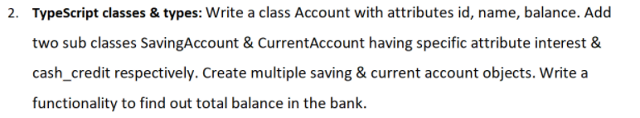

<!DOCTYPE html>

<html>

    <head>

        <title>demo</title>

    </head>

    <body>

        <h3>TypeScript classes & types</h3>

        <script src=Assignment3.ts></script>

        </script>

    </body>

</html>

class Account{

    constructor(id,name,balance)

    {

        this.id = id;

        this.name = name;

        this.balance = balance;

    }

}

class SavingsAccount extends Account{

    constructor(id,name,balance,interest)

    {

        super(id,name,balance);

        this.interest = interest;

    }

    totalBalance = () => { this.balance += this.interest;

        console.log(this.balance);};

}

class CurrentAccount extends Account{

    constructor(id,name,balance,cashCredit)

    {

        super(id,name,balance);

        this.cashCredit = cashCredit;

    }

    totalBalance = () => { this.balance += this.cashCredit;

        console.log(this.balance);};

}

let S1 = new SavingsAccount(1001,'Vinita',40400,4000);

let S2 = new CurrentAccount(10003, 'anna', 30000,3800);

S1.totalBalance();

S2.totalBalance();

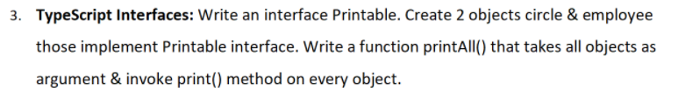

<!DOCTYPE html>

<html>

    <head>

        <title>demo</title>

    </head>

    <body>

        <h3>TypeScript Interfaces</h3>

        <script src=Assignment3.ts></script>

        </script>

    </body>

</html>

interface Printable{

    fname?:string;

    id?: number;

    area?:Number;

};

let circle :Printable ={

   area: 720,

};

let employee :Printable = {

    fname: "Aneela",

    id:10001,

};

function printAll(circle, employee){

    console.log(circle);

    console.log(employee);

}

printAll(circle,employee);